|  |  |
| --- | --- |
|  | **2019 연세-넥슨 √*i***  **RC 창의플랫폼 중간보고서** |

|  |  |
| --- | --- |
| **프로젝트명** | AutoTime |
| **모임 일시 및 장소** | 1. 4.19(금) 19:00~21:00 (1기숙사 7층 세미나룸)  - 참석자 : 피주원, 최기주, 김종현, 문제웅  - 논의내용 : Finalization of the project idea and deciding on roles.  2. 5.1(수) 19:00~21:00 (1기숙사 7층 세미나룸)  - 참석자 : 피주원, 최기주, 김종현, 문제웅  - 논의내용 : Ordering microwave and tools.  3. 5.15(수) 18:00~20:30 (지혜관C)  - 참석자 : 피주원, 최기주, 김종현, 문제웅  - 논의내용 : Took apart a microwave and studied its operations and functions.  4. 5.20(목) 19:00~21:00 (진리관B 206호)  - 참석자 : 피주원, 최기주, 김종현, 문제웅  - 논의내용 : Discussed design layout and started on electronics  5. 5.22(수) 19:30~21:30 (1기숙사 7층 세미나룸)  - 참석자 : 피주원, 최기주, 김종현  - 논의내용 : Researched electronic parts and ordered them  6. 5.27(화) 19:00~21:00 (진리관B 206호)  - 참석자 : 피주원, 김종현, 문제웅  - 논의내용 : Discussed further on electronics  7. 6.20(화) 14:00~16:30 (진리관B 206호)  - 참석자 : 피주원, 김종현, 문제웅, 노재학  - 논의내용 : Discussed on how the software will be developed and how the electronics will be implemented in the microwave.   * 총: 피주원(14시간 30분), 김종현(12시간 30분), 문제웅(12시간 30분), 최기주 (10시간 30분), 노재학 (2시간) |
| **참여 인원** | 치원 하우스 피주원 (대표), 치원 하우스 김종현, 알렌 국제 하우스 문제웅, 운동주 하우스 최기주, 백양 하우스 노재학 |
| **프로젝트 목적** | To create a ‘smart’ microwave that automates several processes such as setting the time by using a barcode scanner. By implementing WiFi, it can keep track of new products store the data in the case it is unable to connect to the internet. |
| **진행된 사항** | Currently, we have a firm grasp on the areas we have to research and develop. By taking apart a microwave, we were able to study on how the microwave functions. Using this, each members have been assigned roles to do during the term break. The electronics team are have already started with the designs and part selections and the software team laid out the ground work and structures to further develop upon. |
| **향후 계획** | During the term break, we aim to complete the software for the core functionalities of the microwave such as the barcode reader and the microwave communicating with a server. Afterwards, the software iterations will be generally quality-of-life improvements and aesthetics. During the break, the designs for the electronics are to be completed and afterwards ordering and printing parts. These are to be completed by late September. After these two parts are completed, assembly of the final prototype and promotion of the product are to be done at October. Preparation for the RCCP fair in November. |
| **예산집행**  **내역** | |  |  |  |  |  | | --- | --- | --- | --- | --- | | **내용** | **수량** | **내역** | **총금액** | **비고** | | Experimental Microwaves | 1 | - | 30000\ |  | | Soldering tools | 1 | - | 12000\ |  | | 총 비용 |  |  | 32000\ |  | |
| **기타** |  |

**기록/확인 피주원**

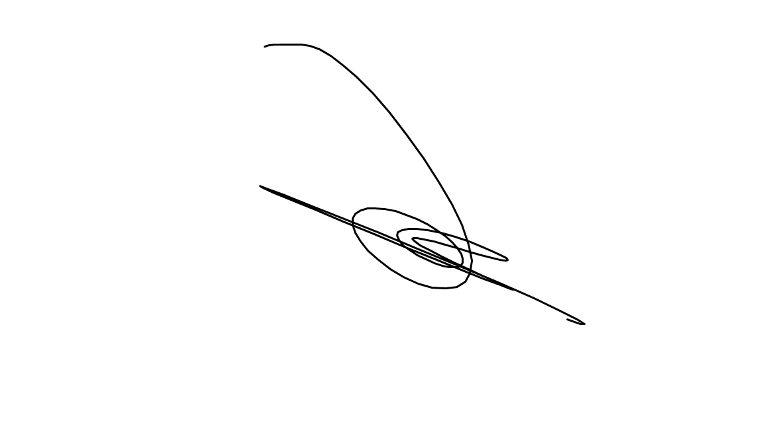

**검토/승인자 RM 김선정 (서명)**

**# 별첨(회의록 및 회의사진: 회의 등 모임을 가진 경우 각각의 모임별 회의록과 회의사진을 별첨 제출)**